Social Story for Sensory Storytime at Cabanne Library

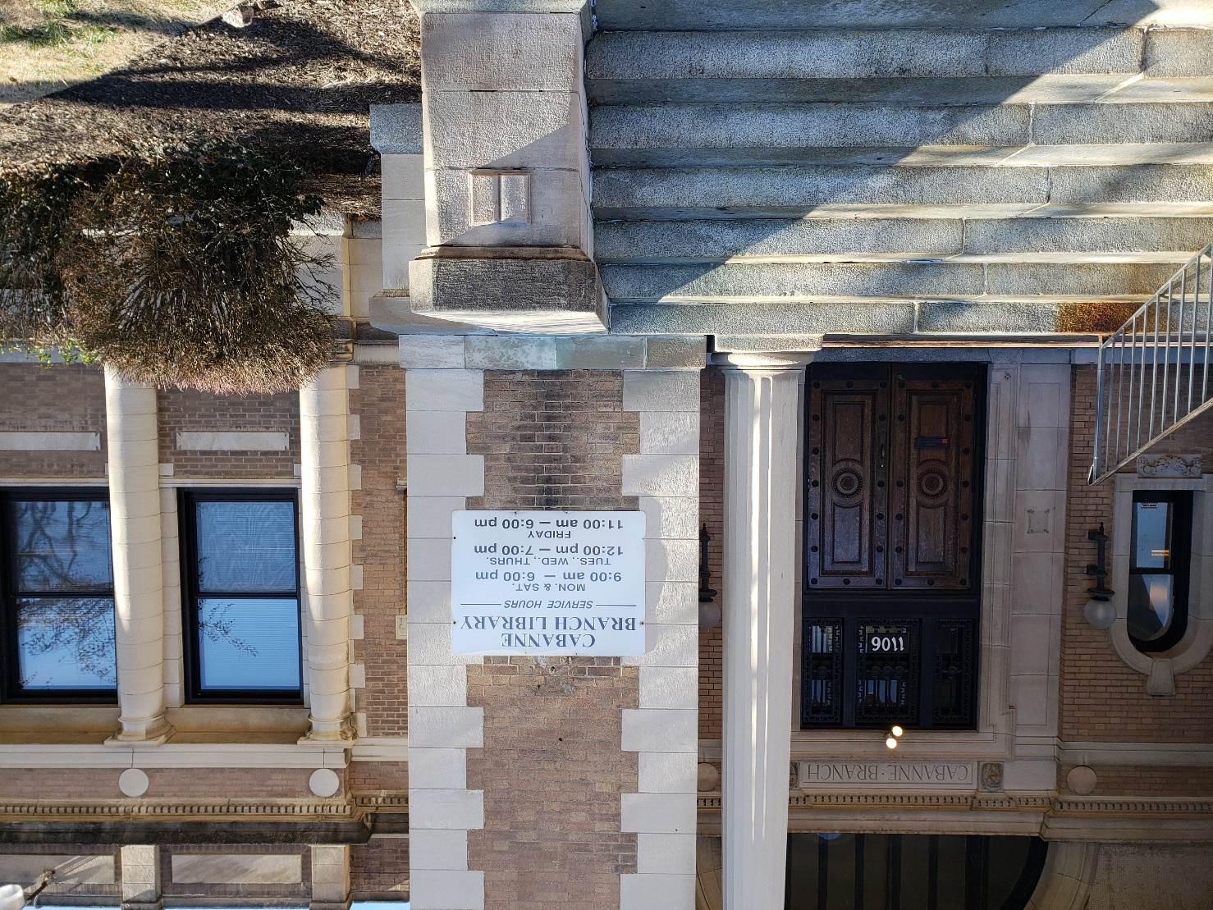

I am going to Storytime at Cabanne Library.

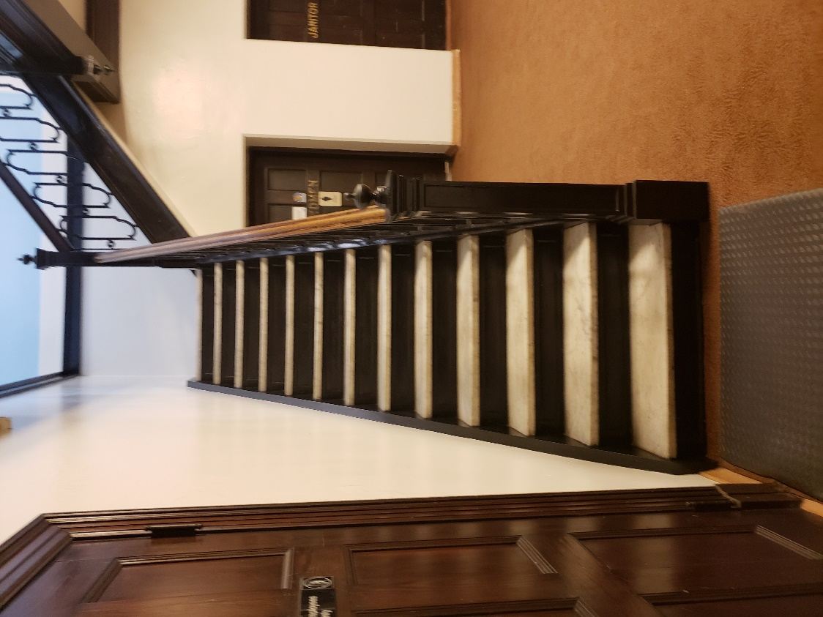
I go downstairs to Storytime in the Auditorium.

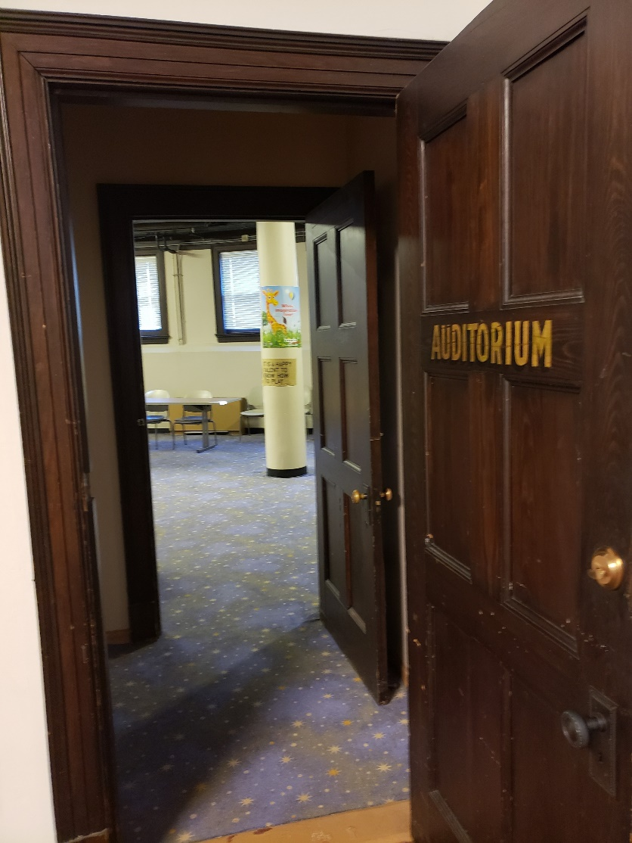

This is the Auditorium entrance.
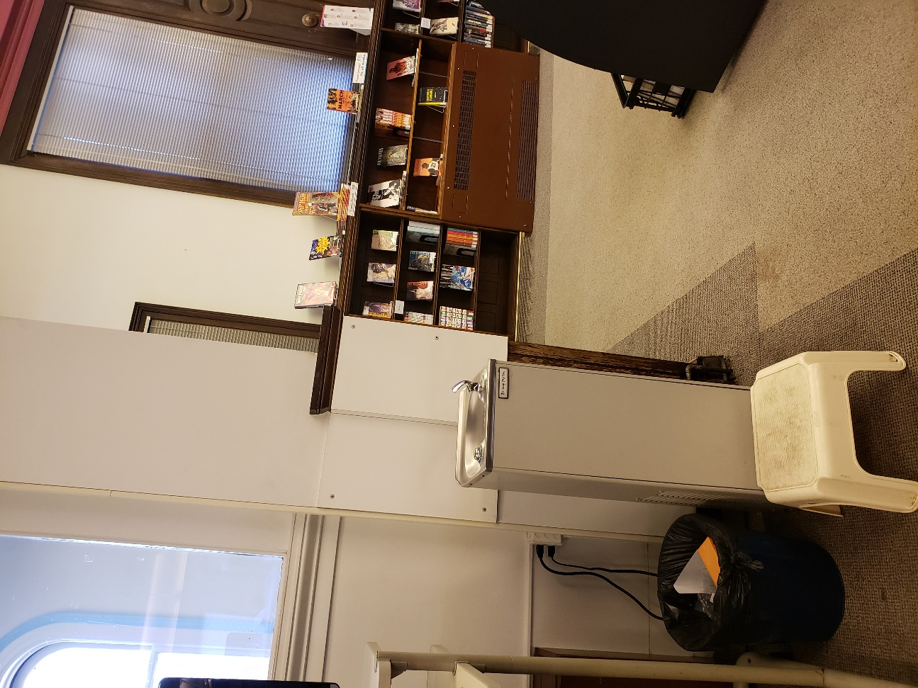
When I get thirsty, there is a water fountain upstairs next to the computer.
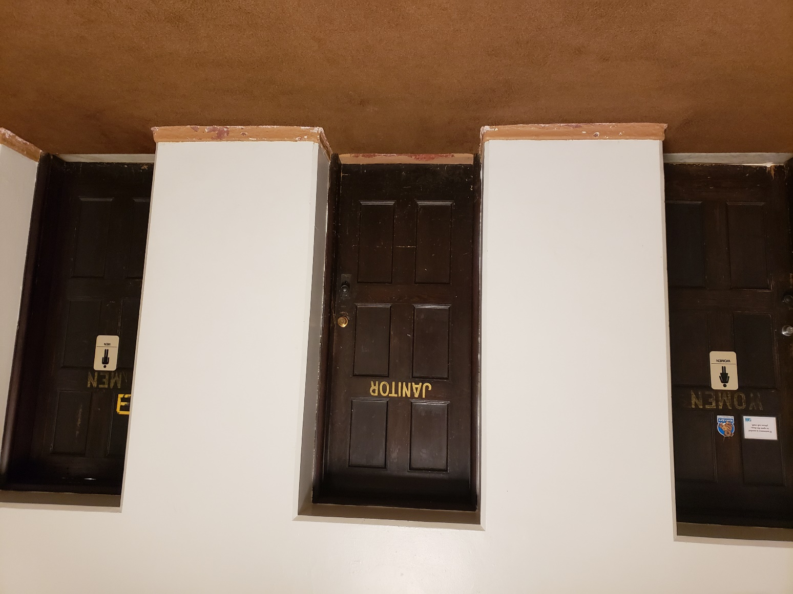
If I need to use the restroom, there is a special one just for me and my caregivers across from the Auditorium.

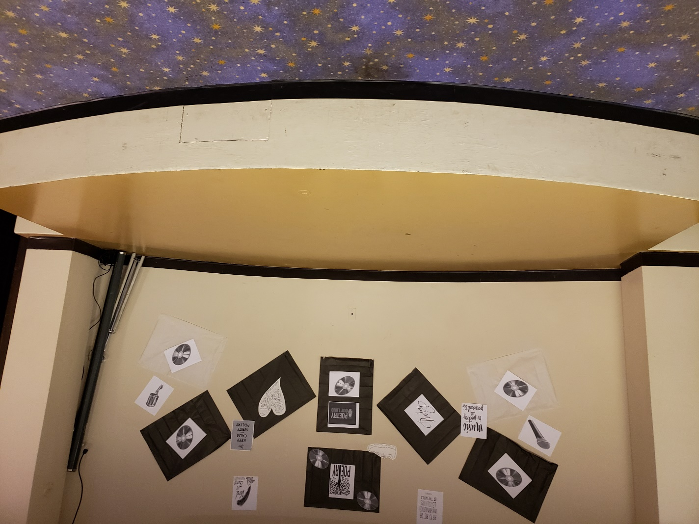
Just before Storytime begins, I sit down on the carpet in front of the stage.

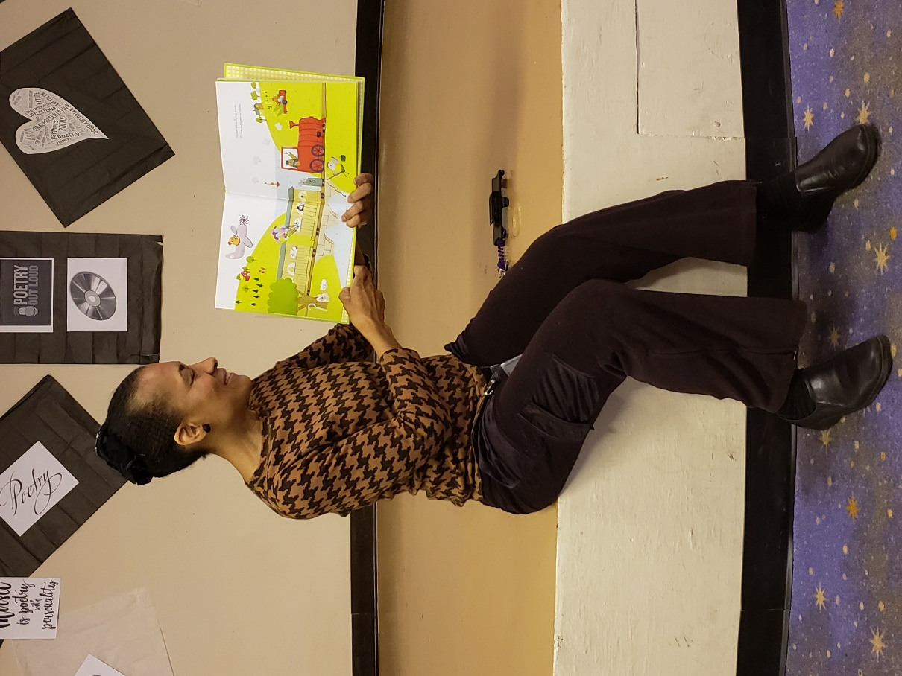
Miss Brooks welcomes me, reads, and tells us stories.

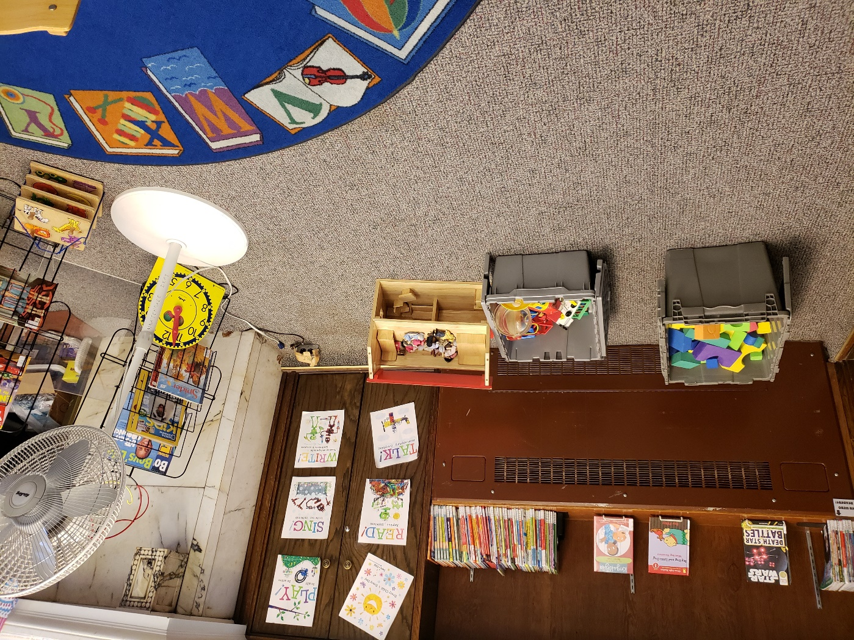
At the end of Storytime, if I want, I can stay to play with toys and the other children.

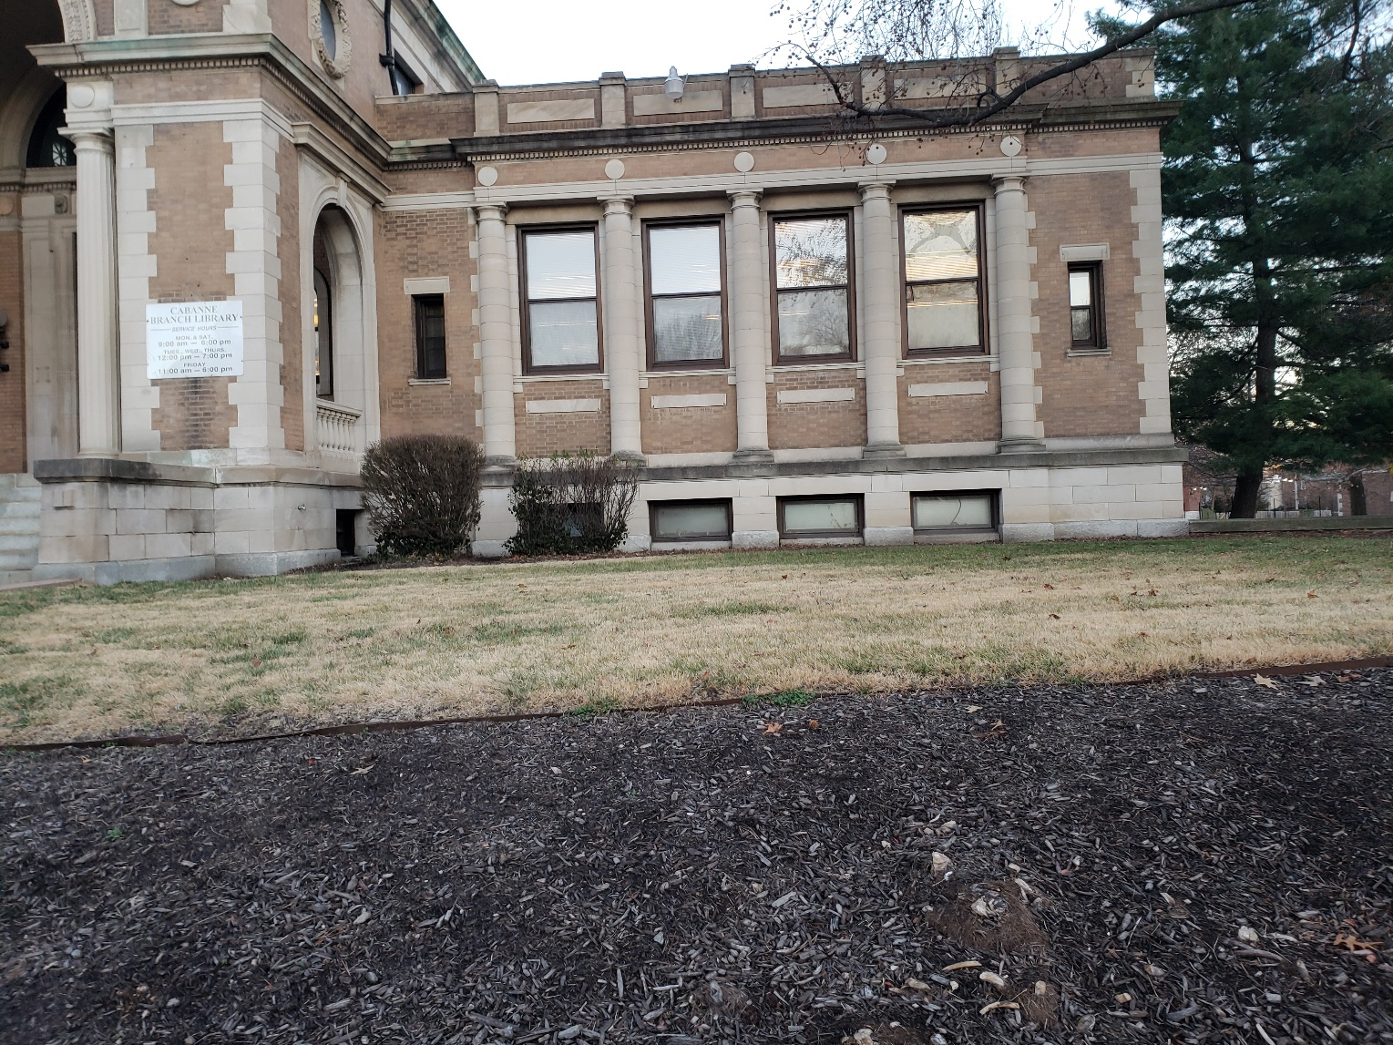
After Storytime is over, we all go home.

