Social Story for Sensory Storytime at Buder Library

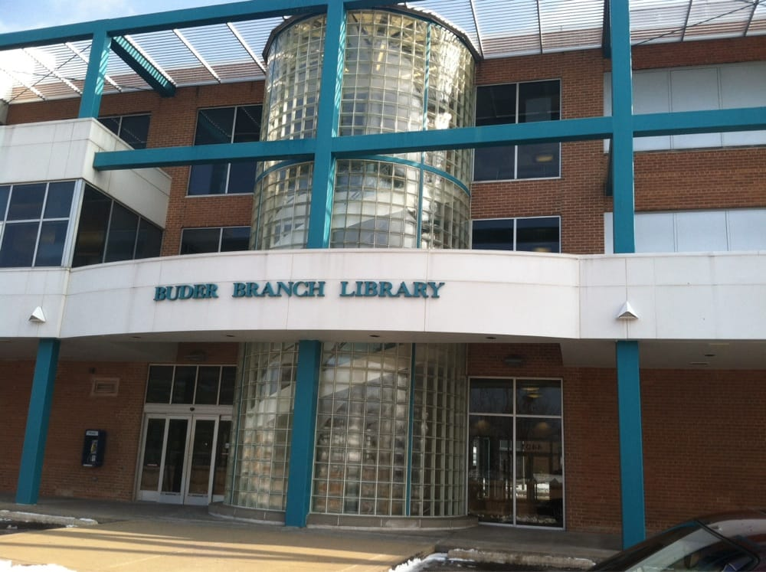
Today I am going to Storytime at Buder Library.
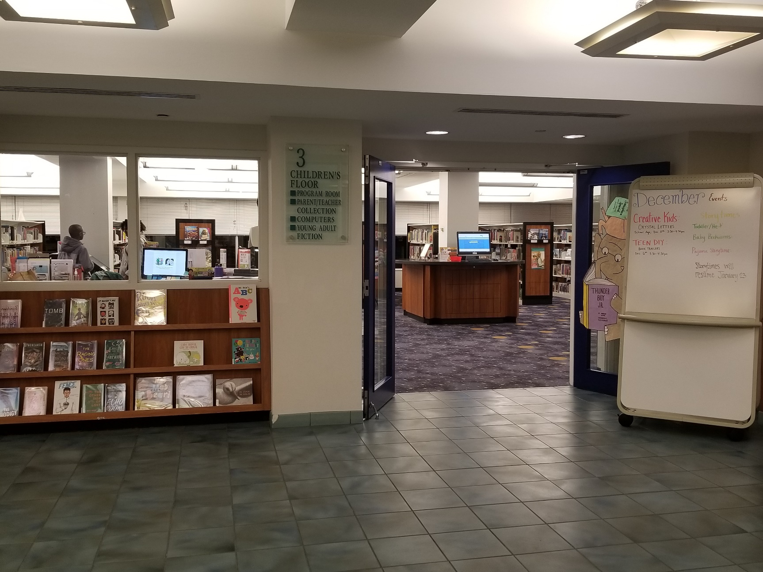
This is the Children’s Library Entrance.
In the Children’s Library, I can read books, play games, or play on the AWE computers before or after Storytime.
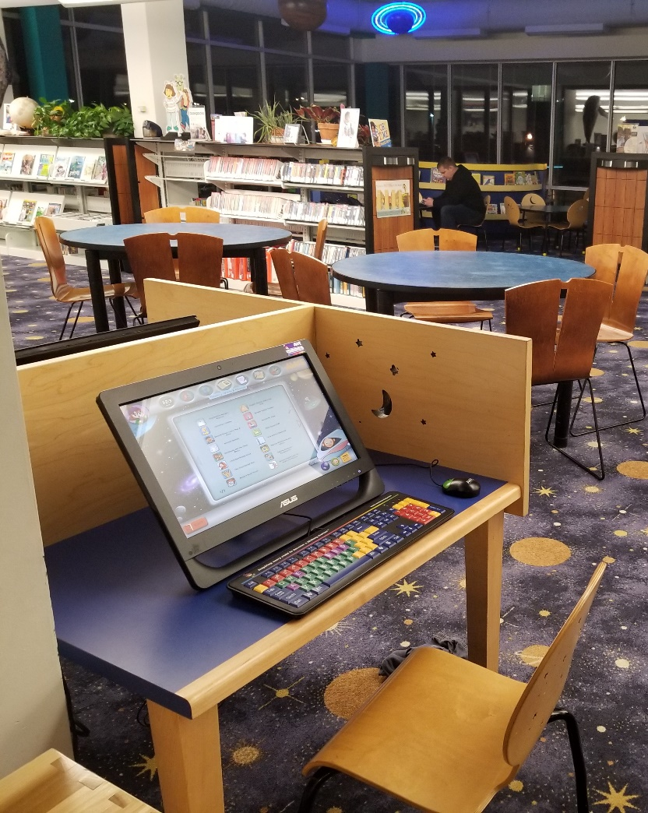
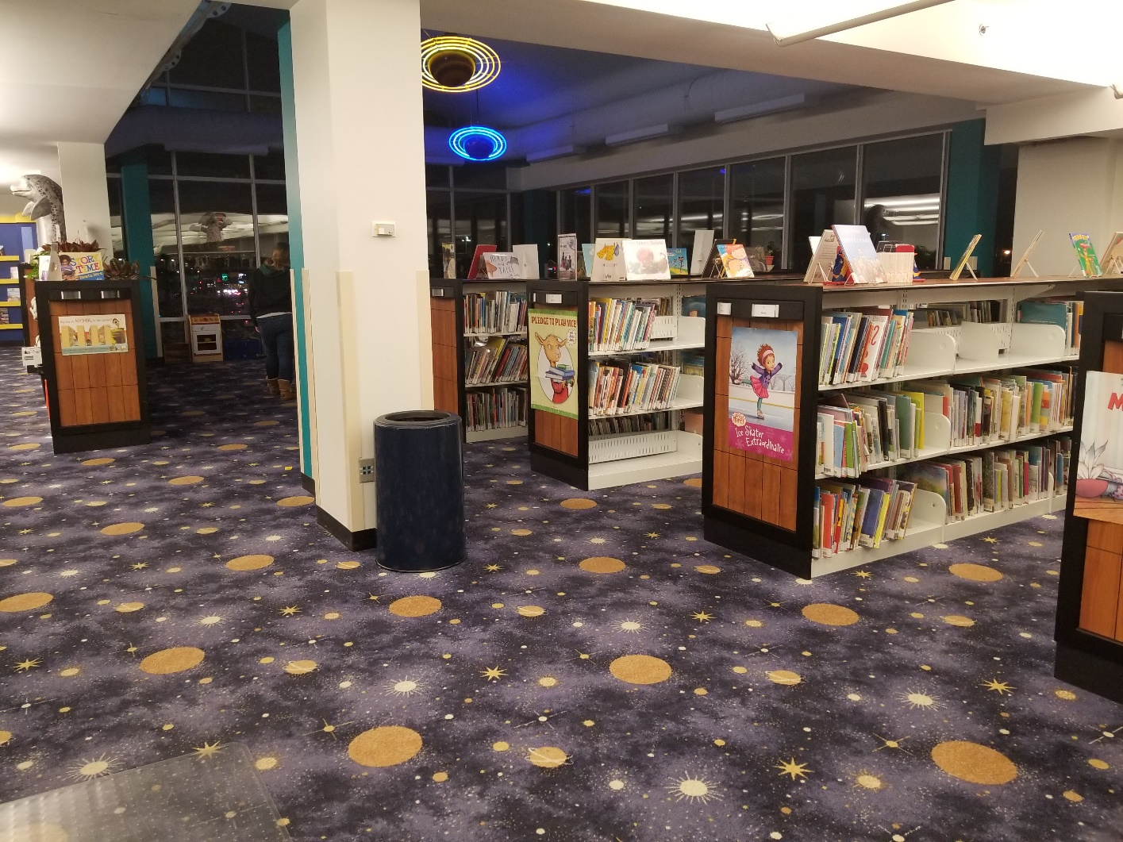
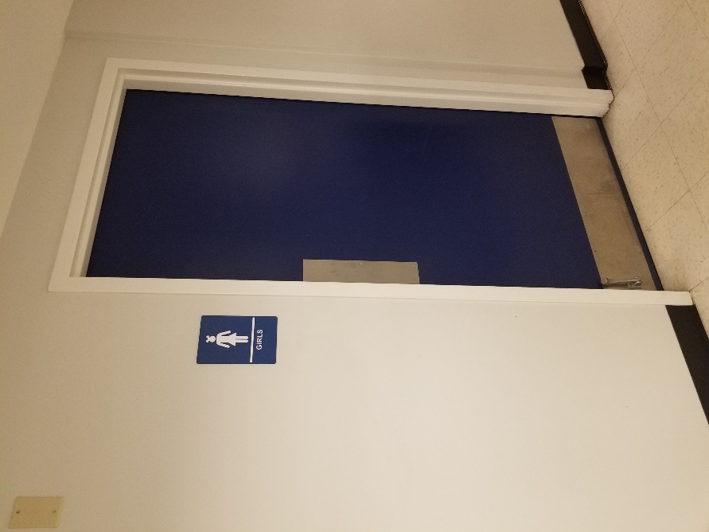
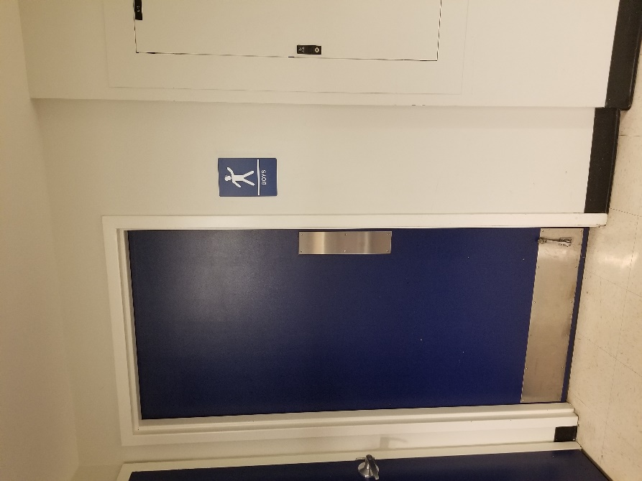
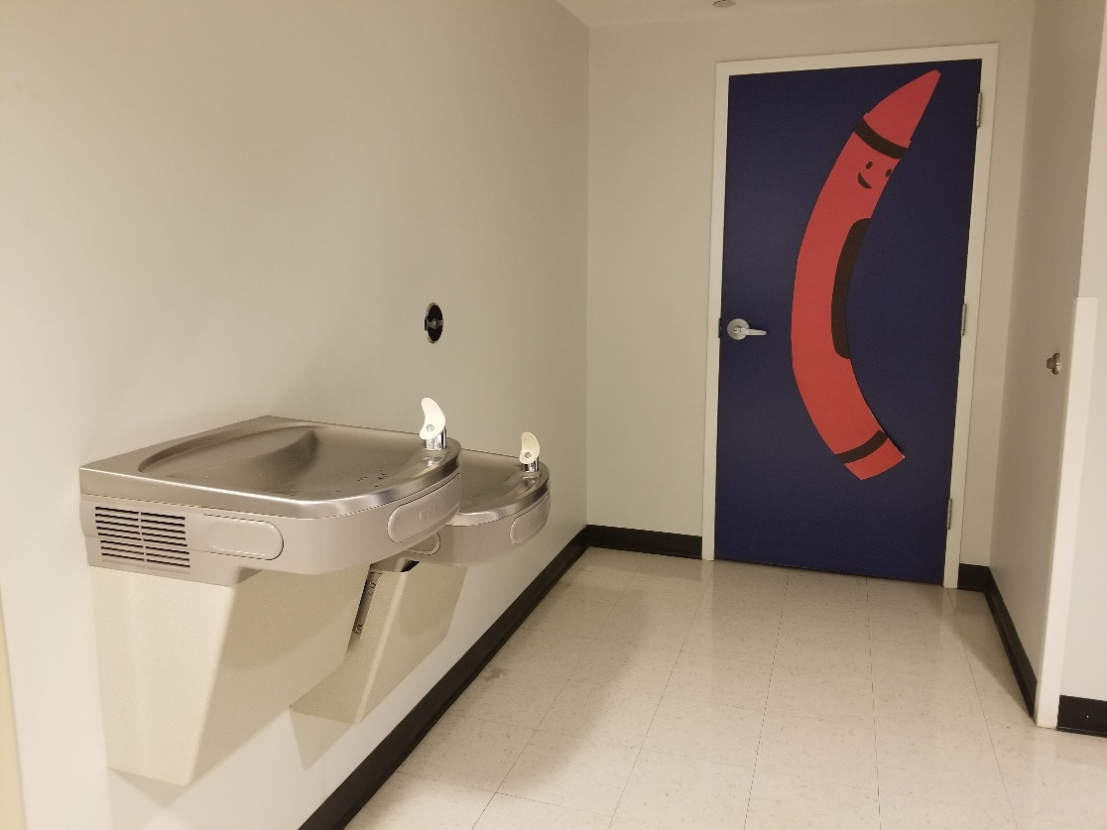
When I get thirsty, there is a water fountain where the red crayon is, and if I need to use the restroom, there is are two in the hall next to the water fountain.

Just before Storytime begins, I go to the Storytelling Area.
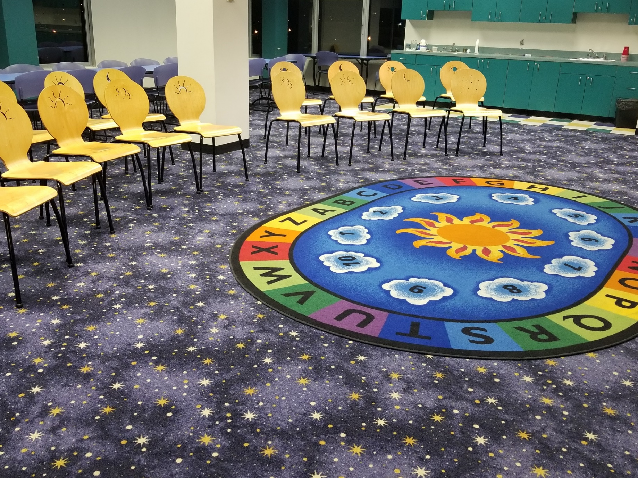
OrEither
Either Miss Sara, Miss Erin, or Miss Krista welcomes me and reads and tells stories to us.

Miss Sara Miss Erin Miss Krista
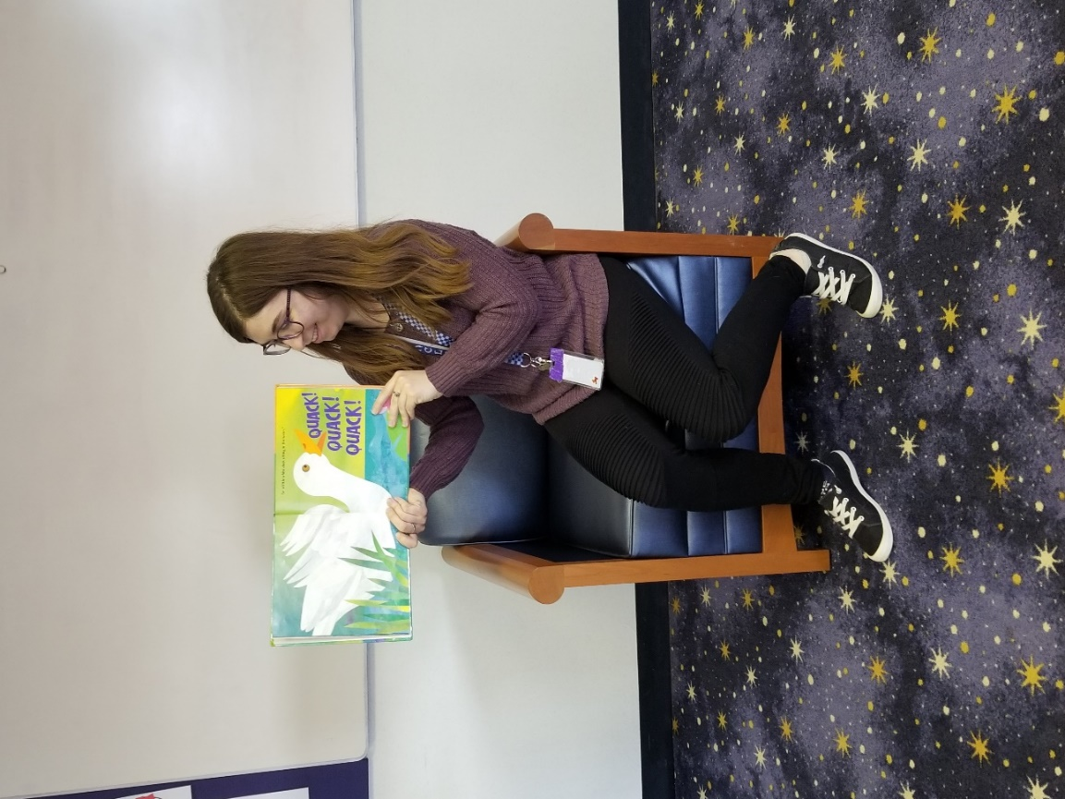
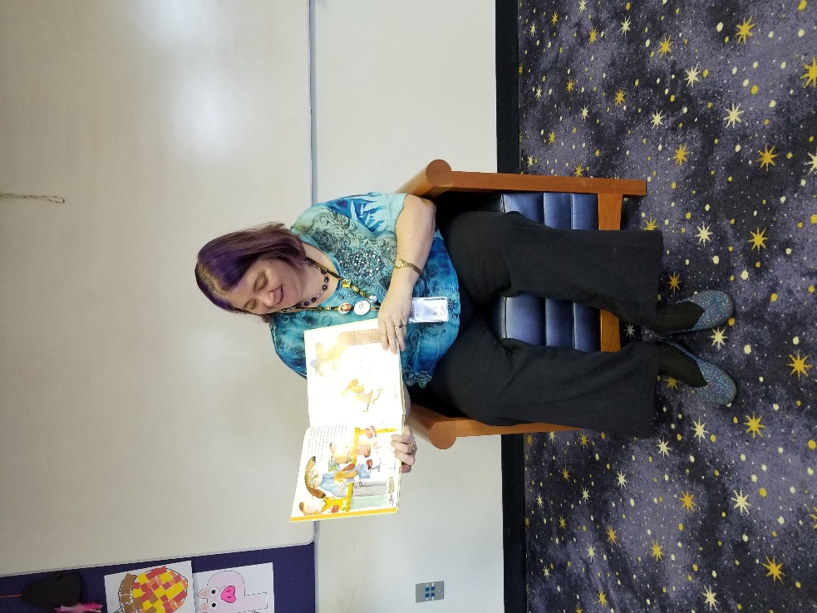
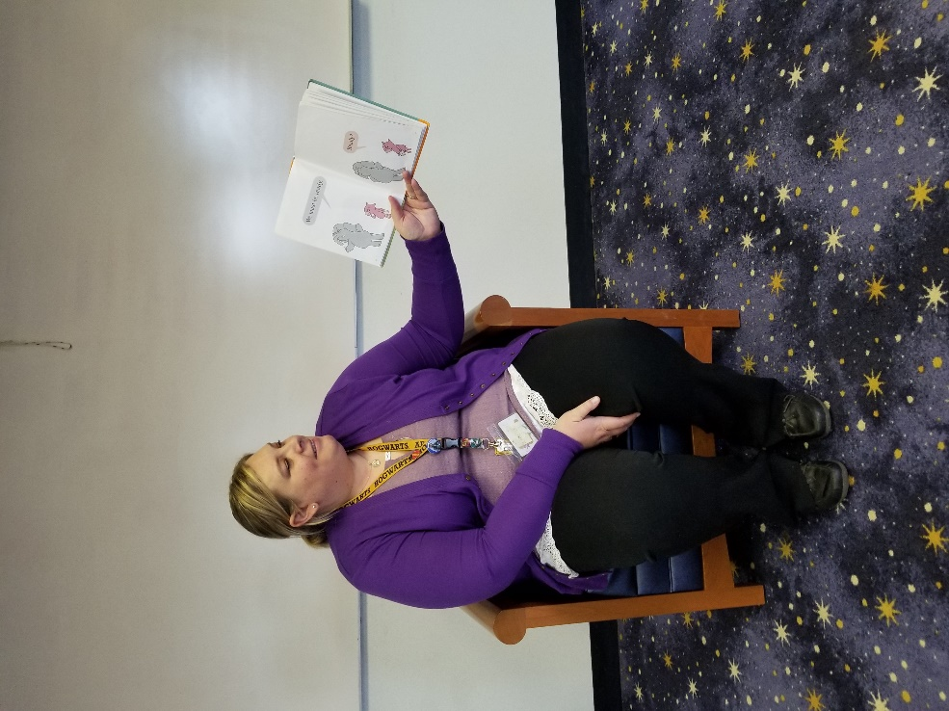

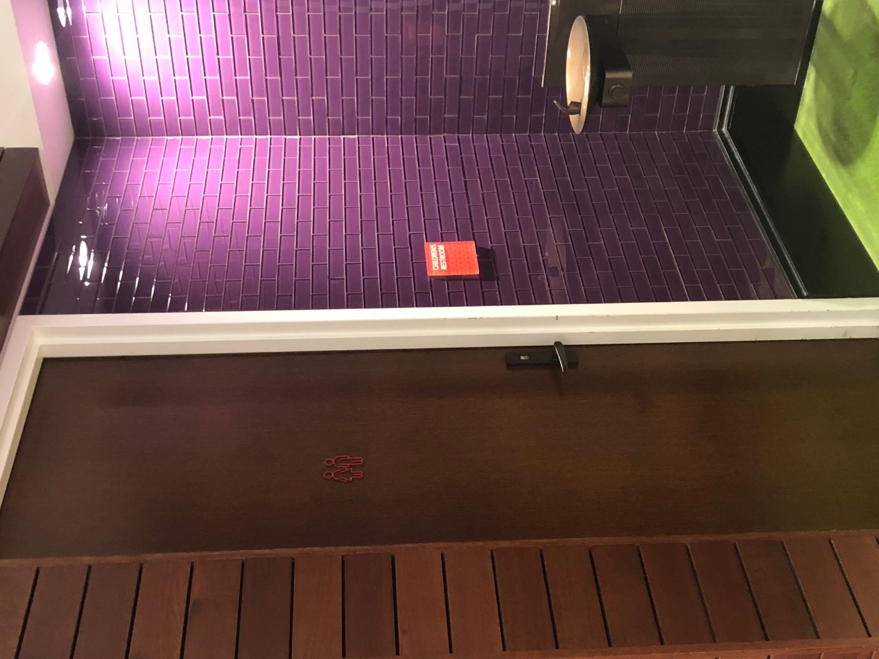
At the end of Storytime, I stay to play with toys and the other children.
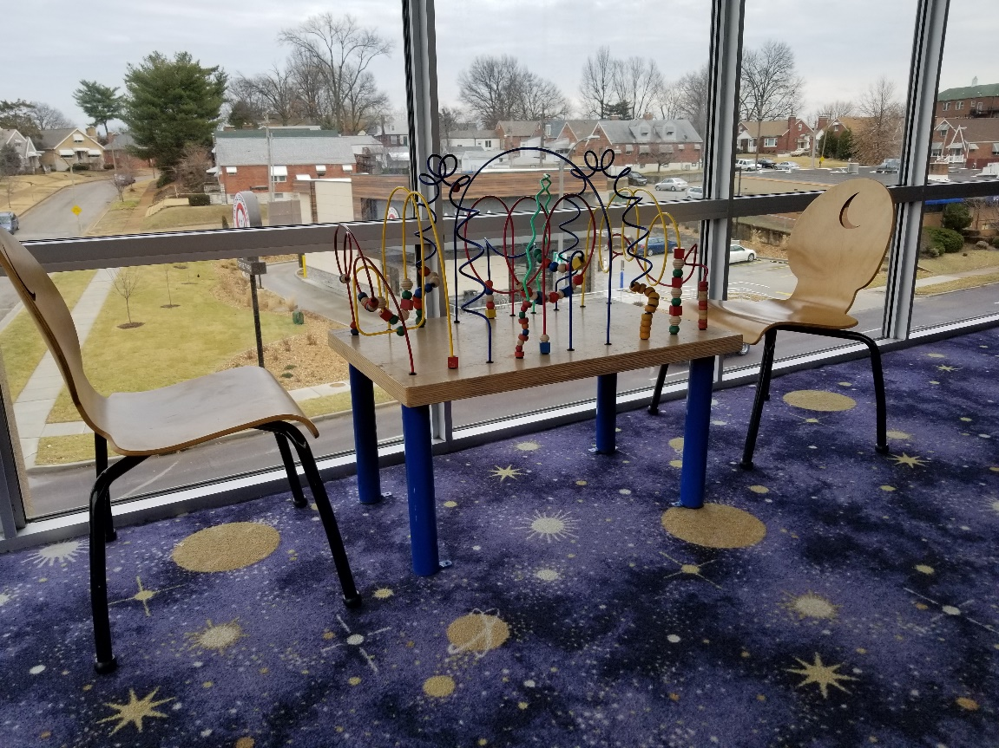
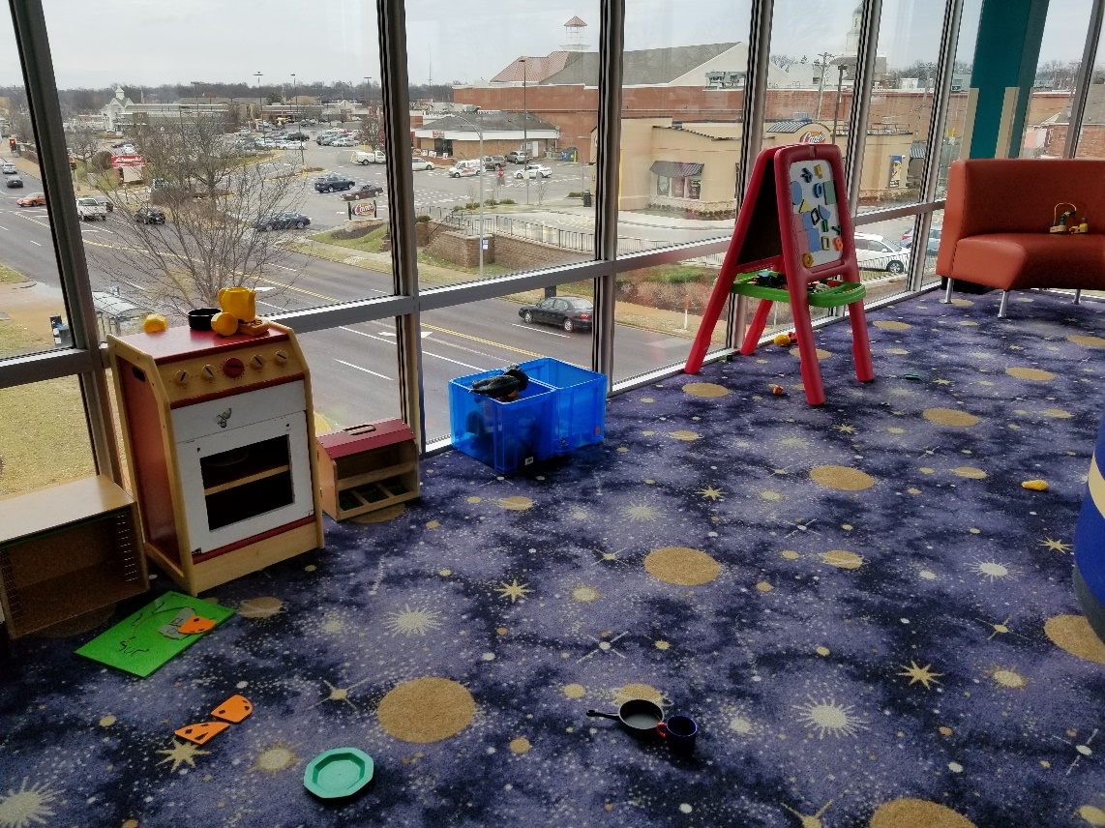

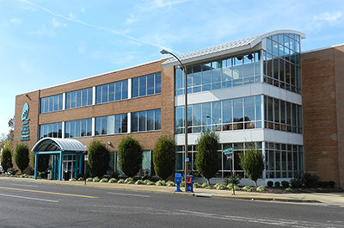
After Storytime is over, we all go home. I am not sad because I know I will come back for the next Storytime.

